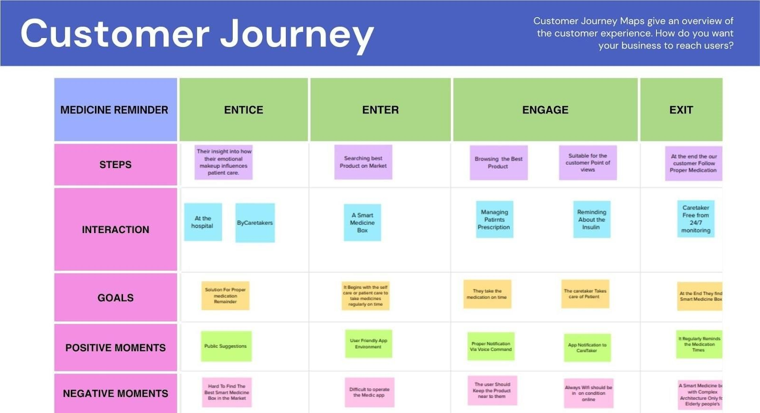

**PROJECT**

**DESIGN**

**PHASE**

**-**

**II**

**CUSTOMER**

**JOURNEY**

**MAP**

**:**

Date

16

October

2022

Team

ID

PNT2022TMID19314

Project

Name

Personal

Assistance

for

Seniors

Who

Are

Self

-

Reliant

Maximum

Marks

4

Marks